This is to certify that

Rotec Hydraulics Limited (Taunton)

is a full member conforming with the BFPDA Code of Conduct
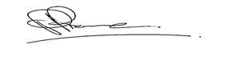
Valid from: 1st January 2016 Signed Chairman BFPDA
Valid until: 31st December 2016

This certificate is the property of BFPDA and issued subject to the above conforming to the BFPDA Code of Conduct

